**Name: Ezra Samuel**

**Project 2: Udagram – Your Own Instagram on AWS**

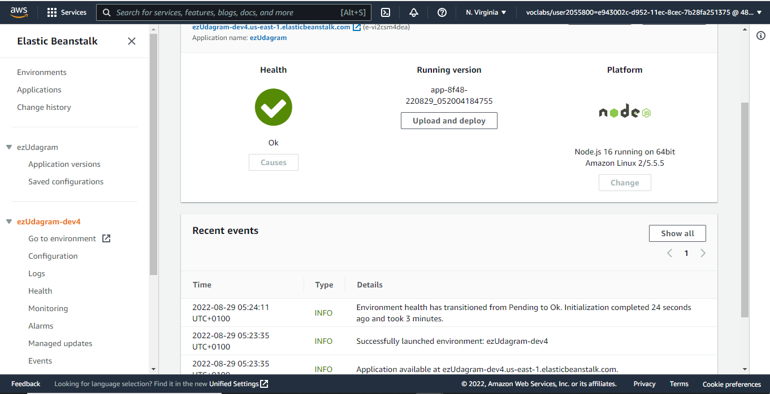

1. Screenshot of the elastic beanstalk application dashboard after deployment.
2. Link to the endpoint URL for a running elastic beanstalk deployment:

ezUdagram-dev4.us-east-1.elasticbeanstalk.com

1. Github Repository:

https://github.com/ezraone/ezUdagram